B37VB – Final Report
Elliot Thompson – H00504281 – emt4000@hw.ac.uk
Aanya Rath – H00504716 – ar4043@hw.ac.uk

Table of Contents
Table of Contents 1
Revision History Table 1
Introduction 2
Theory 2
LDR circuit 2
PWM motor control 2
Light-Tracking algorithm 3
Conga line 3
Results 4
LDR codes 4
PWM values 4
Conclusion 7

Revision History Table
Date | Author Name | Version Number | Notes
26/03/2026 | Aanya Rath | V1 | Creating the document and added some theory
28/03/2026 | Elliot Thompson | V1.1 | Finished theory
02/04/2026 | Elliot Thompson | V1.2 | Wrote conclusion and results
03/04/2026 | Aanya Rath | V1.3 | Wrote introduction
03/04/2026 | Aanya Rath | V1.4 | Added content to PWM values results

Introduction
We were given a buggy with an Arduino, breadboard attached to its front and two motors attached to two wheels. Our main task was to make our buggy follow a light when it shined on either LDRs. In addition to this, we were also tasked with PWM motor control, so our motors were not powered directly by a voltage source and instead it was connected to the Arduino, this also makes it easier to control the speeds as it is connected to the microcontroller, so with appropriate code we could change the speeds. We used the oscilloscope to prove this by producing positive duty cycle waves. The last task we performed was the Conga-line with three different buggies. Our buggy was the leader buggy, which had a light on its back and another buggy had to follow this light. The follower had another light on its back, which the final buggy would follow. Out of all three tasks, the last one was the most challenging task, as the speeds of the three buggies had to be adjusted continuously to make it work.

Theory

LDR circuit
The circuit consisted of a LDR and a fixed resistor connected in series with an ADC connected to the node between the LDR and fixed resistor. The supply voltage is connected to the LDR, and the fixed resistor is grounded. This is so the ADC measures the voltage on the fixed resistor. When there is a high illumination the LDR has a low resistance so the voltage over the fixed resistor is high. This is because the LDR and fixed resistor are a potential divider, so the supply voltage is split between them. The voltage over one of the components can be found using the equation V_{R1}=R₁/(R₂+R₁) * V_{S}. The ADC would measure the voltage over the fixed resistor so when illumination is high the voltage over the fixed resistor is high so the ADC measures high. If the LDR was grounded and the fixed resistor was connected to power, then a high illumination produces a low voltage input. This is not ideal as a high illumination source would associate to a low input from the ADC, so a high source is reversed to low. The ADC works by turning the measured voltage into a binary code. The ADC used was able to produce 2¹⁰ codes from 0 to 1023. The ADC measures the voltage over the fixed resistor and then converts it into a binary code. This code is processed by the micro controller and can power motors with varying values as the code changes. The values of the fixed resistors were chosen by looking at the resistance of the LDRs at standard light conditions. It is best that these values match so any changes to the illumination would be easily observed by the code from the ADC changing.

PWM motor control
PWM was used to power the motors instead of a direct voltage source. This is because of the energy efficiency of PWM as it loses less energy to heat. PWM can also be controlled using a microcontroller so the speed of the motors can be varied. The microcontroller relies on the code coming from the ADCs from the LDR circuits to control the speeds of the motors. The codes are compared against thresholds to determine if it should drive forward, turn or stop. Each speed of the motor comes from a square wave with a different duty cycle. A duty cycle is a percentage of the on period and the total period of a wave. The pulse width modulation of each motor was found by disconnecting the wires from the microcontroller and connecting it to the oscilloscope. The settings on oscilloscope were set to positive duty cycle, and the scale was adjusted accordingly.

Light-Tracking algorithm
The thresholds we used for our light-tracking code were: 100 for the difference between the two LDRs for turning and 1000 for the maximum amount of light for the buggy to fully stop. For moving forward, we used 150. Our reversing PWM values were -150 for both, for turning left our PWM values for left and right were 100 and 200 respectively whereas for turning right our PWM values were 200 and 100 respectively. In addition to this our turn duration was set to 100 milliseconds. For turning the buggy, the difference between the left and right LDR is taken and if it is greater than the threshold (which is 100) it would then compare the left and right LDR values, set the LDR to turn in that direction by setting either its left or right PWN turn value and finally set the turn duration. For moving forward, only if both LDRs are not going above the threshold value (otherwise both PWM values are set to zero) the forward PWM value is assigned to the left and right motors. In both cases of turning and moving forward, the function “UpdateMotorSpeed” is called, however the only difference being that the duration for moving forward was set to 0.

Conga line
For the conga line to work a lightbulb had to be mounted on the back of the buggy so that a different buggy could follow its light. The lightbulb would flash on and off for a certain amount of time which was determined by the total number of buggies in the conga line and the ID of that buggy. The buggy behind would detect how often the light is on and off for and work out the ID of the one in front. If that buggy’s ID is one more than the one it is detecting then it will follow, otherwise it will not. The circuit for the lightbulb was a FET transistor, with the gate connected to the microcontroller on the Arduino, the drain connected to the lightbulb which was powered by a 5V voltage source, and the source was connected to ground. The lightbulb had a maximum allowed current of 400mA. A suitable transistor had to be chosen that had a high enough maximum allowed current or alternatively multiple transistors could be put in parallel to divide the current. The transistor used in the circuit was a BS170 FET transistor which had a maximum current of 500mA. This was more than the lightbulbs, so one transistor was needed to build the circuit.

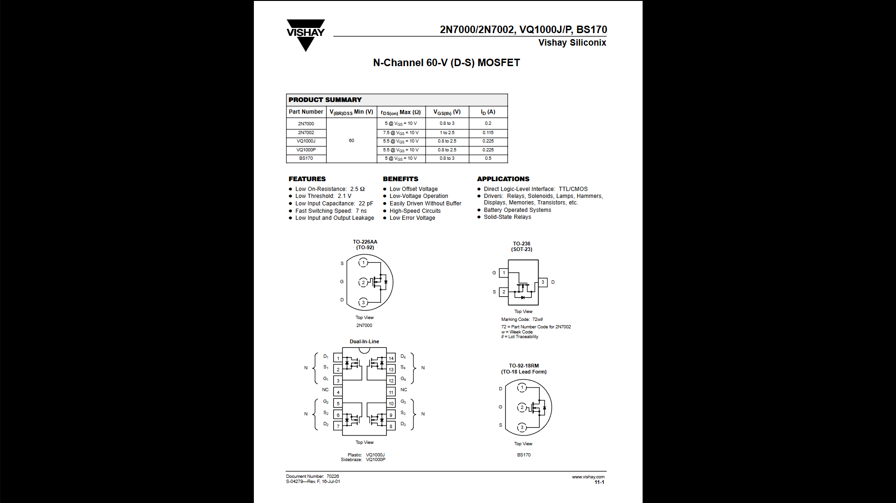
Figure 1. BS170 datasheet

Results

LDR codes
8k resistors were used as they roughly had a code that was near the halfway point of 500 at ambient lighting. At ambient lighting the code was about 620 which is equivalent to 3V. When the LDRs were covered up they produced code which was approximately 370 which is around 1.8V. Finally, when a flashlight from a phone was held up to the LDRs the code maxed out at 1023, so the voltage was 5V. This makes sense as the LDR would have little to no resistance when there is a bright light, so all the voltage would be used on the fixed resistor.

PWM values
We produced a square wave for positive duty cycles of 39.19%, 58.82% and 78.43% respectively, this shows that the motor is fully controlled by the input the LDR receives. These correspond to different PWM outputs used to control motor speed. The duty cycle determines the average voltage supplied to the motor, which directly affects its speed. The LDR readings affect the motors by determining how the PWM values are adjusted in response to light intensity.

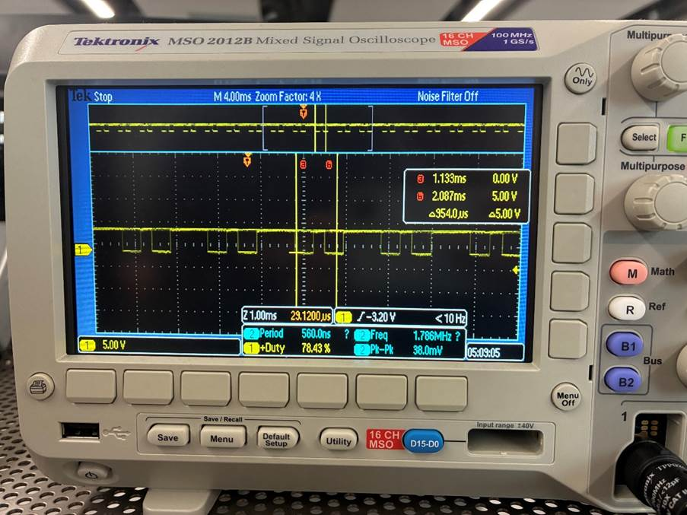
Figure 2. PWM high lighting

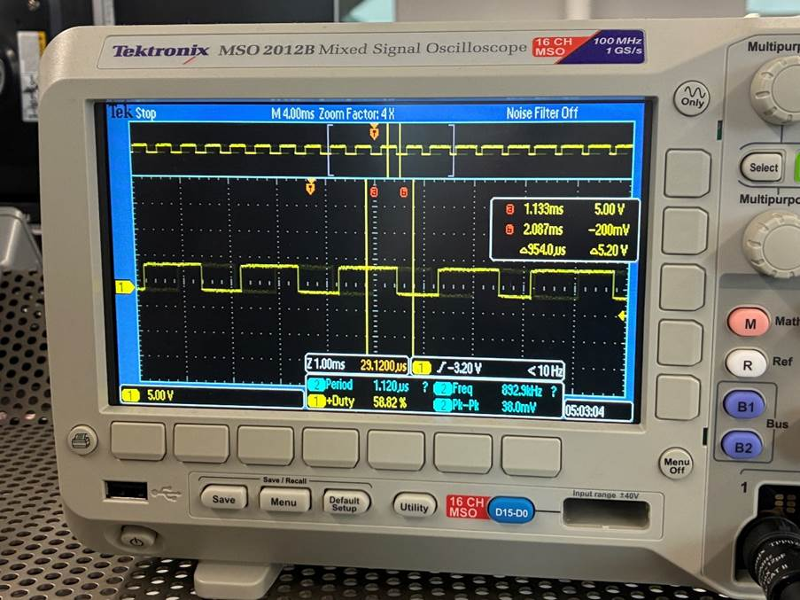
Figure 3. PWM medium lighting

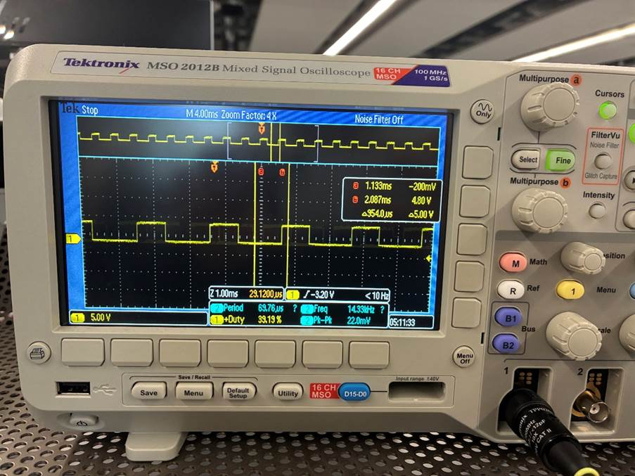
Figure 4. PWM low lighting

Conclusion
Overall, the results were very good and the changes made to the code improved the performance of the buggy a lot. Some lessons learnt during this assignment was that it was better to have a way to change the buggy ID without needing to re-compile it. This would allow for quick and easy changes without the need of a computer to change the code, compile and upload it to the buggy. The solution was to have the ID be controlled by 4 pins which made up a 4-bit binary number. If a pin was connected to a power supply, it would read high which was turned into a 1. If a pin was connected to ground, it would read as low which was 0. This allowed for 16 different IDs to be made from 0-15 by connecting wires in different combinations which allowed the ID to be seamlessly changed by swapping some wires.
Adding a potentiometer or a variable resistor parallel to the fixed resistor would also have proved beneficial, as it would have allowed the fixed resistance to be changed since resistors in parallel effect each other and change the equivalent resistance. This would have allowed for the sensitivity of the buggy to have been changed without adjusting the thresholds. This would have been perfect if we were working in rooms with different ambient lighting.
PID control would have been more useful for the conga line as it allows for the buggy to adjust its speed depending on how close to a light it was. This would have made the conga line much better as the buggies would not constantly stop and start every time they got to close. Instead, the follower would gradually change their speed, so they always keep approximately the same distance from each other.

